

User Manual
WOFATM
Integrate & Accumulate Experiences
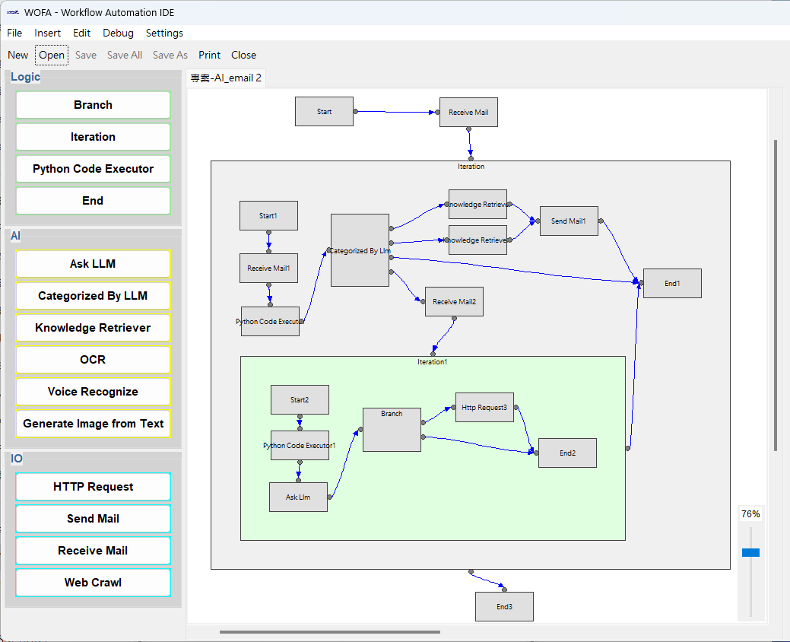
Elevate Corporation Intelligence

Revision Date: 2025-07-25

Content
1. Preface 3
2. Basic Concepts 3
3. Installation 5
4. Basic Operation 6
4.1 File operations 7
4.2 Insert Node 7
4.3 Edit 7
4.4 Debug 8
4.5 Settings 8
4.6 Canvas Area of Projects 8
4.7 Node Editor Area 9
5. Functions 10
5.1 New Project 10
5.2 Insert a New Node 11
5.3 Delete a Node 13
5.4 Setting of regular used LLMs API 13
5.5 Edit the LLMs API for a Project 15
5.6 Setting of a regular used knowledge collection 16
5.7 Edit the knowledge collections used in a project 17
5.8 Edit the variables to be used in a project 19
6. Logic Nodes 20
6.1 Branch 20
6.2 Iteration 21
6.3 Python Code Executor 23
6.4 End 25
7. AI Model Nodes 26
7.1 Asking LLM 26
7.2 Categorize by LLM 27
7.3 Knowledge Retriever 28
7.4 OCR 29
7.5 Voice Recognize 30
7.6 Generate Image from Text 31
8. I/O Nodes 32
8.1 HTTP Request 32
8.2 Send Email 33
8.3 Receive Email 34

Preface
WOFATM is an automation tool designed for AI programmer, which integrated the constantly used modules. With the smart design of the work flow by the programmer, the state-of-art AI technologies can be integrated into, or even simplify the conventional business workflow. Moreover, the accumulation of knowledge collections can embed the intelligence of business operation into the business workflow. Which will to the most extent reduce the frequency of human errors and resources needed.
For the design of the workflow, WOFATM has not only a convenient UI, but also built-in debug functions, which significantly simplify the development works. A carefully designed mechanism of parameters operation, which is more aligned with programmers' intuition. The parameters of regular used LLM APIs can be stored in the settings, which will be convenient to be used in each project. The simplified logic and loop modules can effectively replay the business workflow.
WOFATM also got a server version (runtime), which can be installed on server and been integrated with ERP. The deployment is easy, tools like Docker is not a necessity.

Please feel free to contact syntak.tw@msa.hinet.net, if you have any opinion or suggestions.

Basic Concepts
In any organization which require multiple persons to work together to achieve the goal of the organization, during the proceeding of the cooperation, the missions advance a little bit in each person and transfer to the next one. Among the whole process, some steps might be strictly supervised by a system like ISO9000 quality system, some are only controlled by unwritten procedures among the group members.
No matter which kind of processes they are, there must be someone who knows the details of the process, in order to ensure the details of the mission can be correctly handled and transferred. In the scenario with unwritten procedures, this will be a tough job. Therefore, the process are usually move back and forth.。Whereas in the strictly controlled process, another common problem is: in case there exists a scenario that the procedures do not cover, the process will be on hold until the procedures amended. The amendment of the existing procedures will typically lead another cross-department complex procedures.
The AI technologies advance dramatically lately, which shed a light of solutions to the problems described above. With abundant modules, including logic, AI models and input/output; WOFATM can efficiently construct complex business or industry work flow, communicate with ERP via APIs, and push the progress of work flow automatically (WOrk Flow Automation).
WOFATM is programmed with Python, and the code executor module can execute only Python code.
Every stage in the process is called “node” or “module” or “block”. Before the name is unified within the industry, you might see different name shown in the screen or manuals of WOFATM, they all referred to the same thing.

Installation
Simply implement wofa_ide_win_installer.exe.
Both files wofa_ide_win.exe 和 languages.xlsx will be installed in the directory C:\Users\{user_name}\AppData\Roaming\WOFA_IDE

Basic Operation
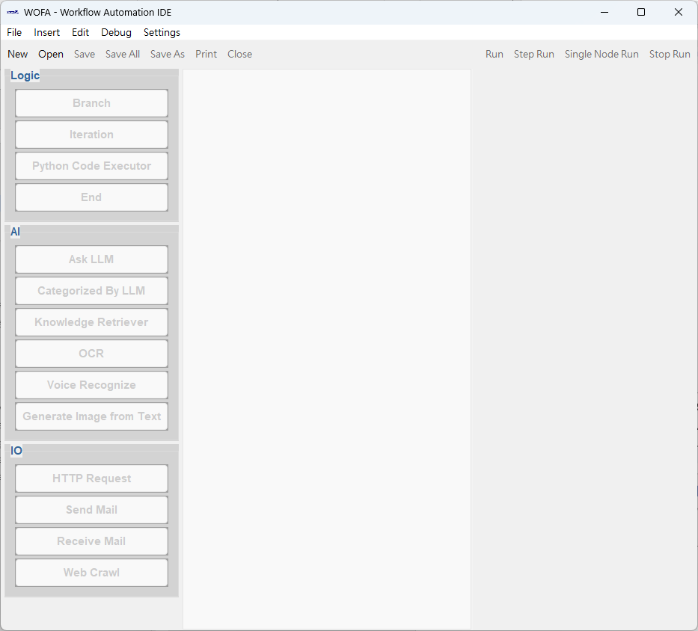
The start screen of WOFATM:

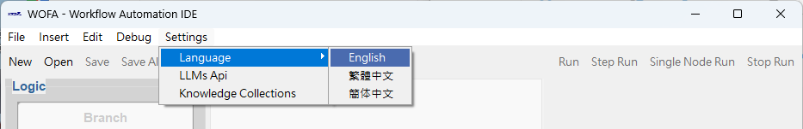
The UI will use your system language as the default. You can also select the language you like in the menu “Settings -> Languge”.

  - File operations
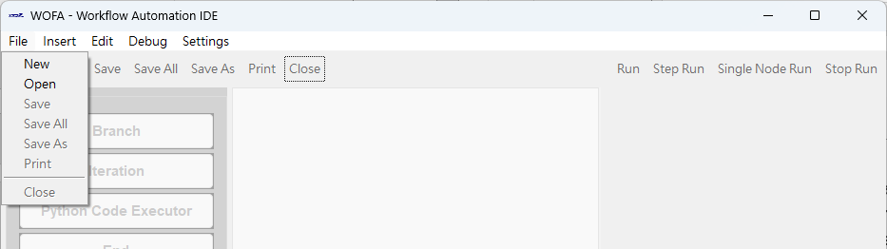
Items New/Open/Save/Save All/Save As/Print/Close are included. The usages of these buttons are similar to most of the Windows App. For the convenience of the user, there are buttons with the same functions in the tool row.

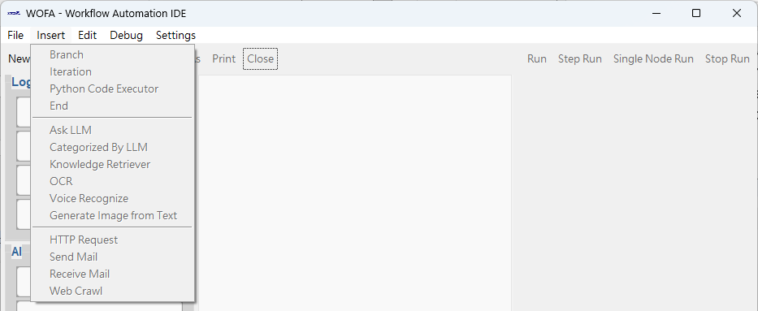
  - Insert Node
3 groups of nodes are included: Logic, AI and IO.
For the convenience of the user, there are also buttons pallete at the left side of the screen. At the time of inserting a node, click on the name of the node in the menu or pallete, move the cursor to the canvas, click again at the location of insertion.

  - Edit
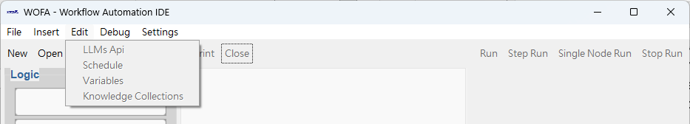
Edit the variables/API settings of AI models/knowledge collections/schedule in the current project.

  - Debug
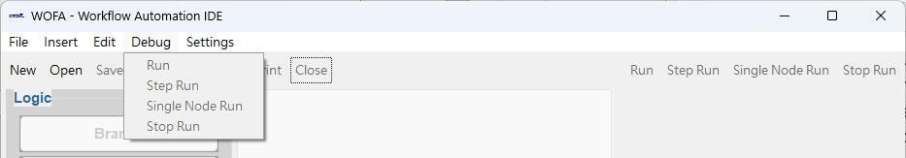
Including Run/Step/Single Node Run/Stop. For the convenience of the user, there are buttons with the same functions in the tool row.

  - Settings
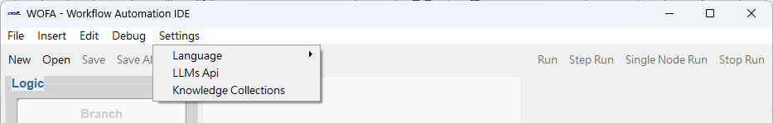
Including Language/Regular used 用LLMs API/Regular used Knowledge Collections.

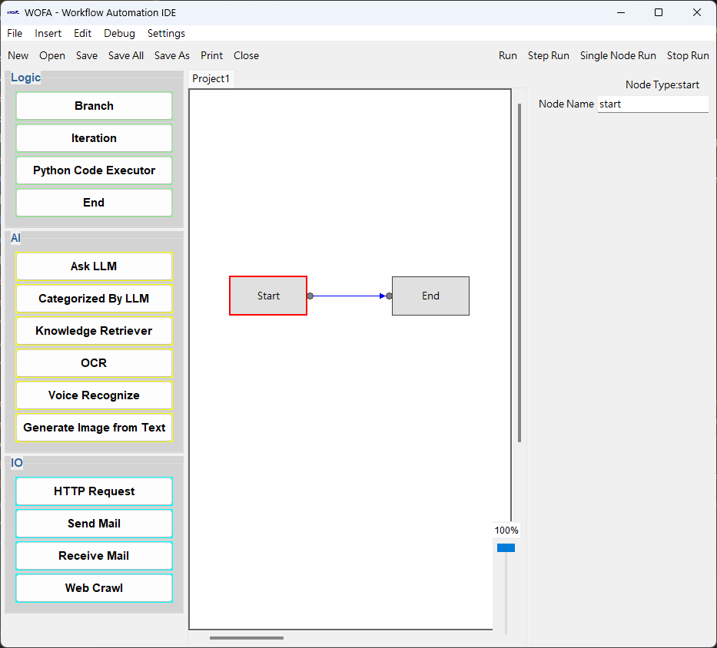
  - Canvas Area of Projects

  - Node Editor Area

Functions
  - New Project
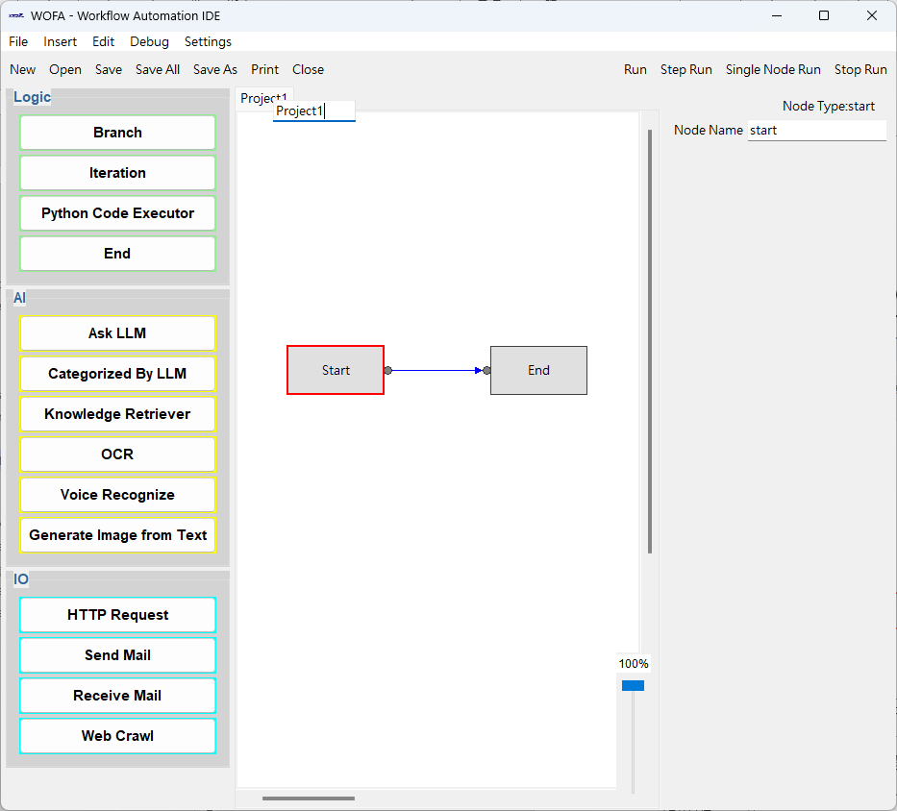
Click the “New” button, you will see a canvas of a new project appearing in the canvas area. In which, two nodes and one connection line will be shown. The name of the new project is shown at the tab, which can be amended by a double click.
In each layer of workflow, there must be one and only one Start Node. The workflow will be implemented until the End Node and return to the upper layer, if there is one.
The connection line with arrow means the sequence of the implementation of the workflow.
The node with a read border is the “Node being edited”, its parameters will be shown in the Node Editor Area.

  - Insert a New Node
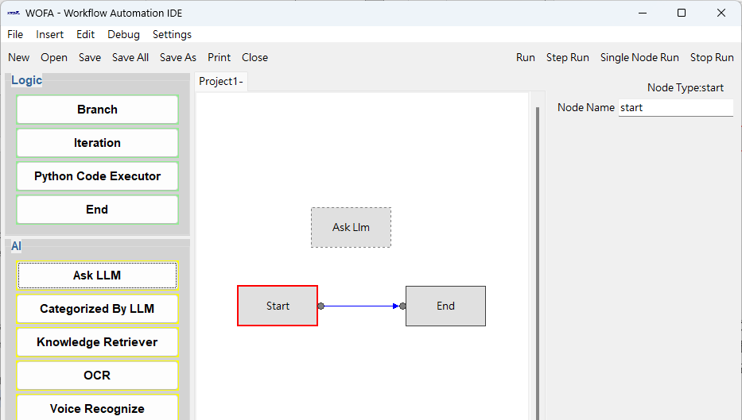
Click the button of the node to insert, the new node will be drawn with dash lines when hovering the mouse over the canvas. Move it to the location to insert and click the left key of the mouse to place the node. The new node will be “node being edited” automatically.

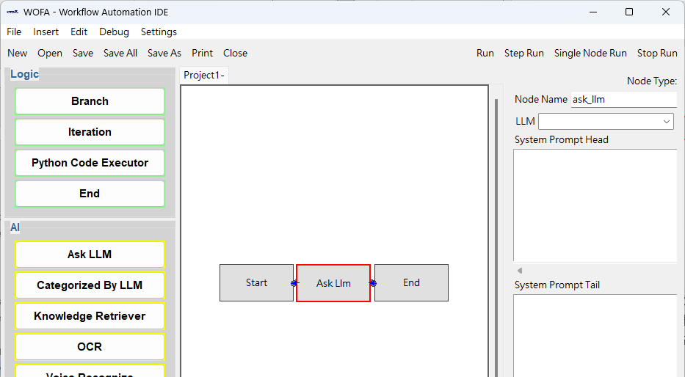
If the new node was placed onto the connection line, the new node will be inserted between the two nodes of the connected by the connection line.

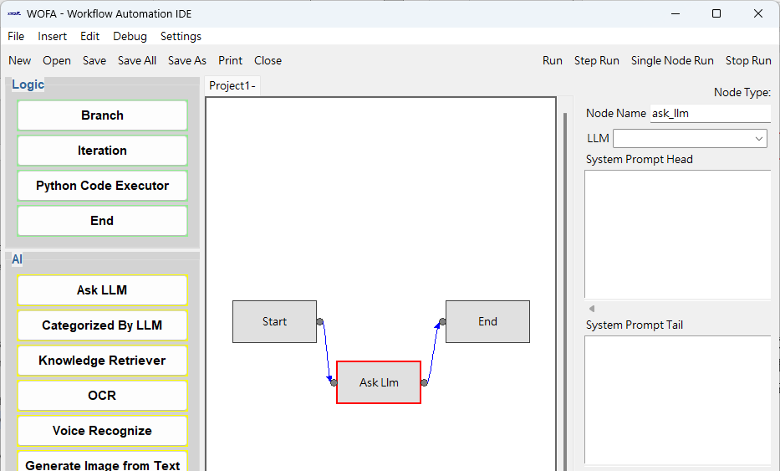
The “node being edited” can be dragged to any location and the connection lines will follow.

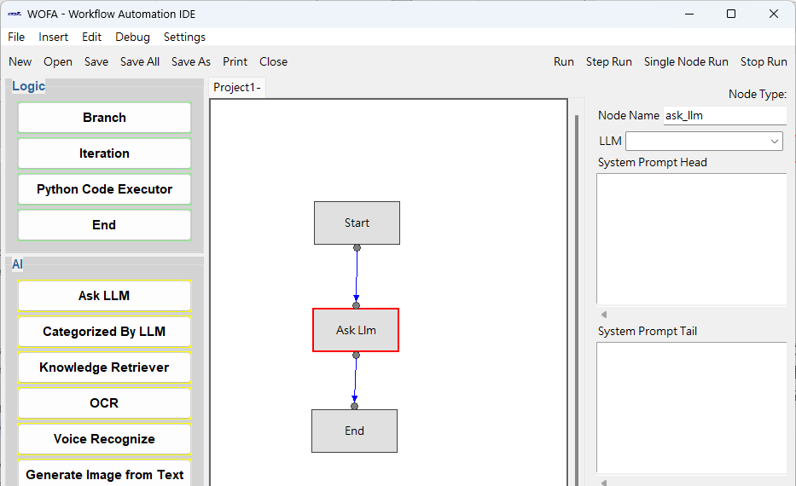
The connection points on the node can be adjusted: the “input” spot can be at the left or top of the node. The “output” spot can be at the right or bottom of the node. The adjustment is done by holding Ctrl key, move the cursor to the location you would like to see the “input” or “output” spot, and then click the left key of the mouse. The connection lines will follow automatically.

  - Delete a Node
Click DEL key will delete the “node being edited”. Make sure the canvas is in focus.

  - Setting of regular used LLMs API
Click Menu “Settings -> LLMs API”, a window will appear:
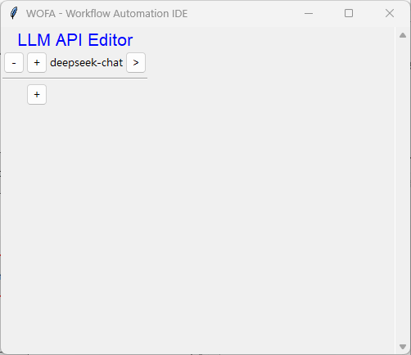
Each row is for one LLM.
Clicking the left “-“ button will delete the row.
Clicking the “+” button will insert a row below.
The “>” button at the right will expand the parameters editor for that LLM API. The “<” button will collapse the editor.
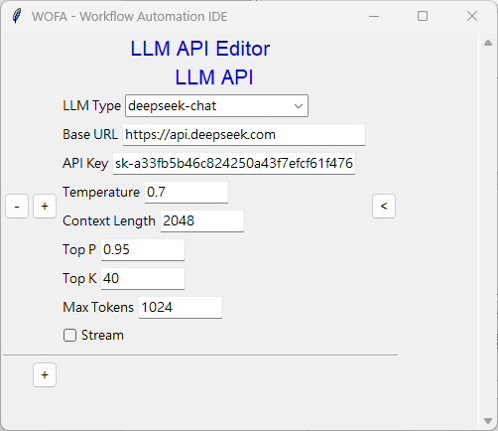
Currently, there are the LLMs available:
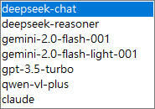
Please acquire the Base URL and API Key from the LLM API you subscribed.

  - Edit the LLMs API for a Project
Click menu “Edit -> LLMs API” and a window will appear:
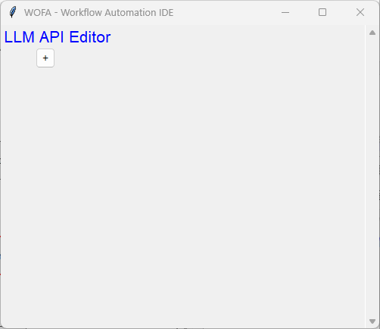
Click “+” button and the following appears:
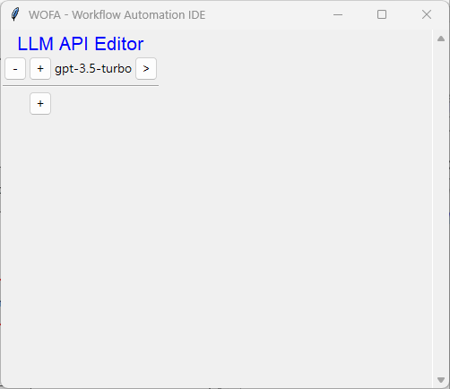

Click “>” button and the following appears:
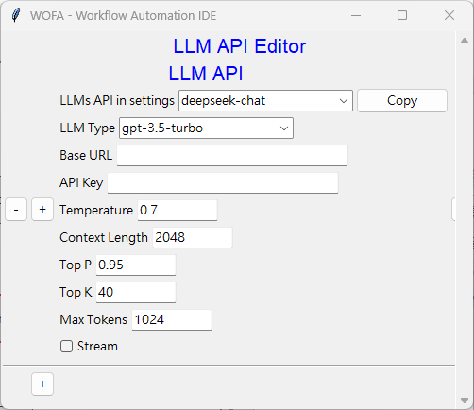
In case there existed the LLM API to use in the settings, you can select the item in the dropdown list and then click the “Copy” button.

  - Setting of a regular used knowledge collection
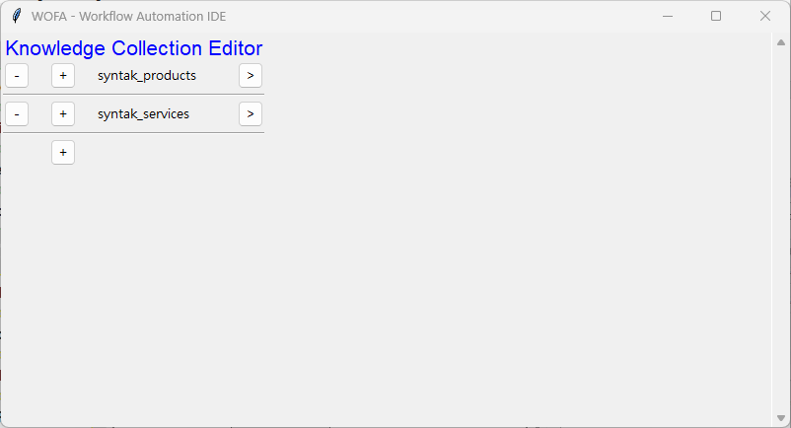
Click menu “Settings -> Knowledge Collections”, a window will appear:

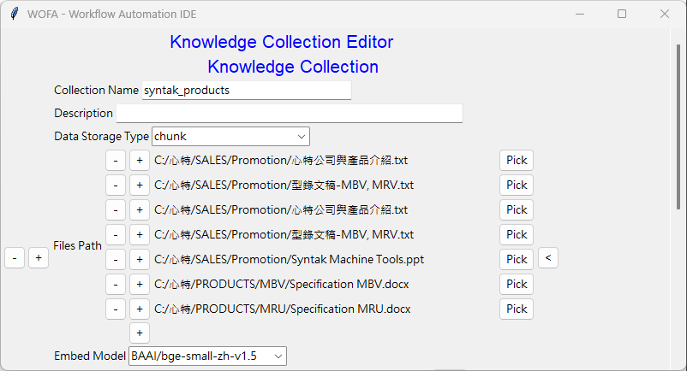
Click “+” button and the following appears:
The data storage type can be either “chunk” or “QA_pair”.
For “QA_pair”, the files can be types of .xlsx, .txt or .json and the formats are:
.xlsx: The first row are the headings, ie: “Question” and “Answer”. Starting from the 2nd row, the questions should be in column A and the answers should be in column B.

.txt:
Q: What is the company name?
A: The company name is Syntak.

.json:
[{“question”: “What is the company name?”,
“answer”: “The company name is Syntak.”}]

Add an empty Files Path and click the “Pick” button to select the knowledge files which had been carefully prepared.
After selecting all the knowledge files needed, click the “Vectorize” button to store the knowledge into the knowledge collection. This process will require a large amount of computation power and the time consumption will depend on the hardware used.

  - Edit the knowledge collections used in a project
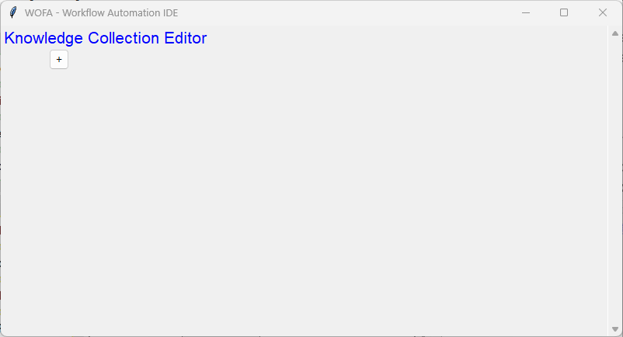
Click menu “Edit -> Knowledge Collections” and the following appear:
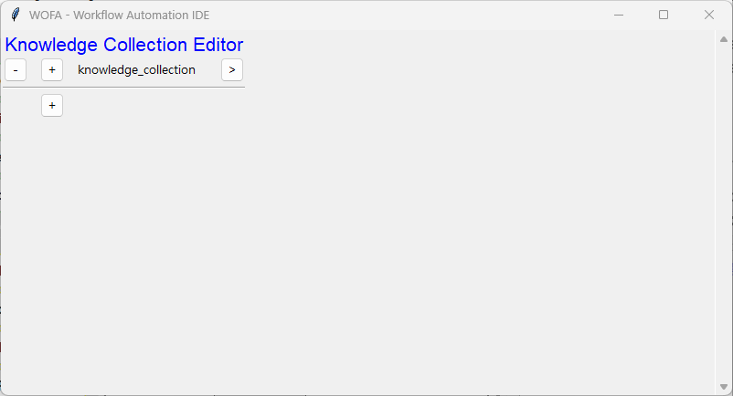
Click “+” button and the following appears:

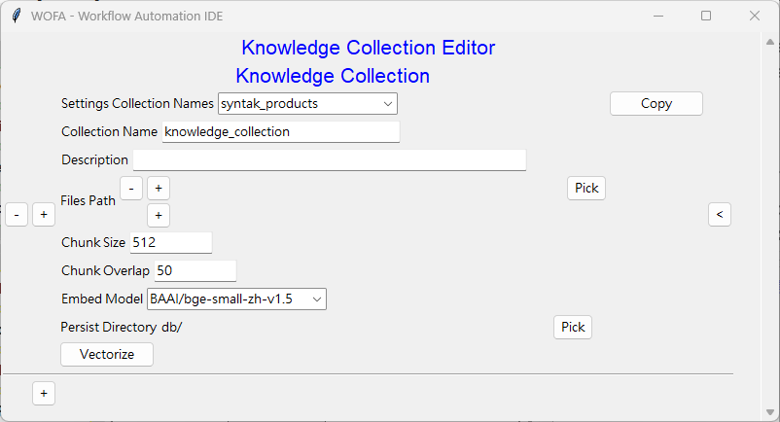
Click “>” button and the following appears:

In case there existed the Knowledge Collection to use in the settings, you can select the item in the dropdown list and then click the “Copy” button.
If the “Vectorize” had been done in the settings, there is no need to do it again.

  - Edit the variables to be used in a project
WOFATM does not pass parameters among nodes, instead, all nodes can access the project parameters table to get the parameters needed.
Click menu “Edit -> Variables” and the following appears:
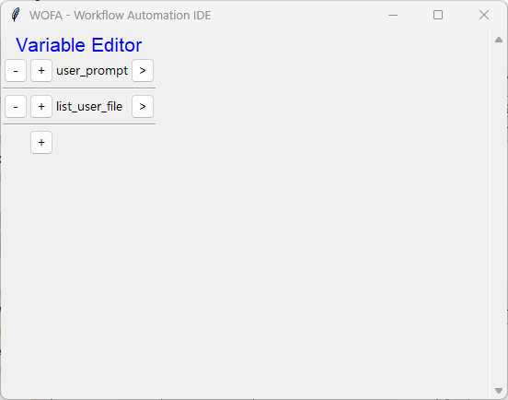
Click the “>” button at the right of the variable to be edited and the following appears:
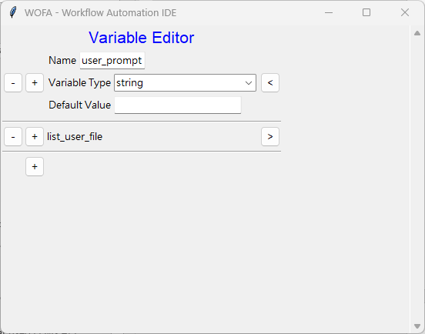

Logic Nodes
  - Branch
The node will decide which branch to continue depending on the result of the evaluator code.
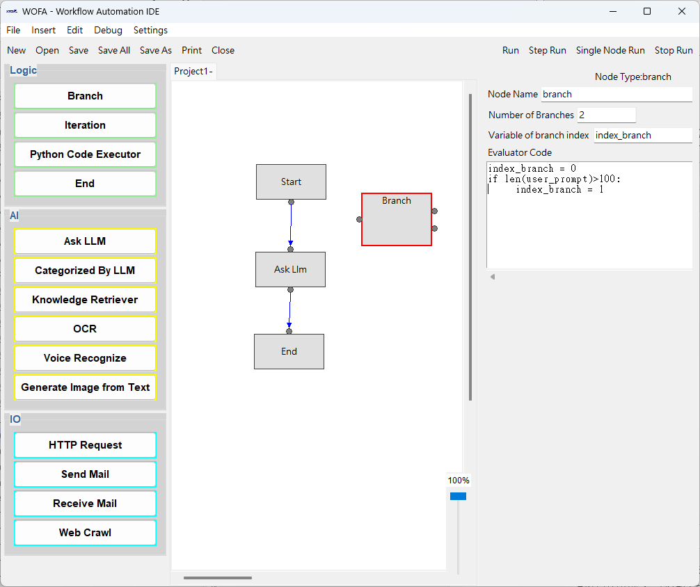
After inserting the node, the following appears:

Number of Branches: The workflow will fork with this number after this node.
The variable of the branch index：the node will look at this variable appearing in the evaluator code.
Evaluator Code: python code to determine which branch to go.

  - Iteration
This node will implement its internal workflow, the values in the list will be iterated and stored in the item variable to be used in each cycle. The index of each item will also be stored in the item index variable. Do remember to add these variables into the project variables table.。
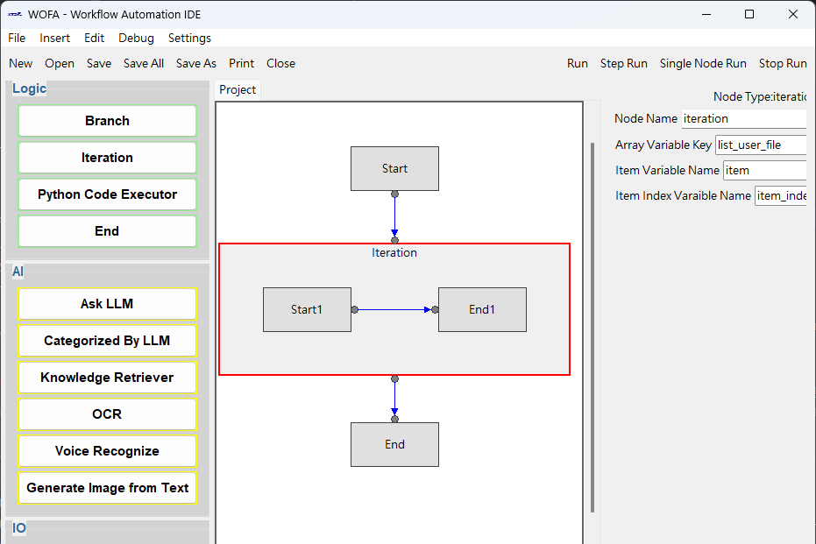
After inserting the node, the following appears:
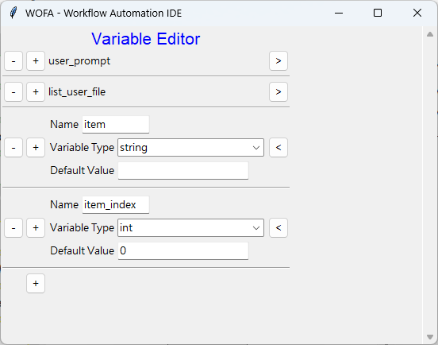

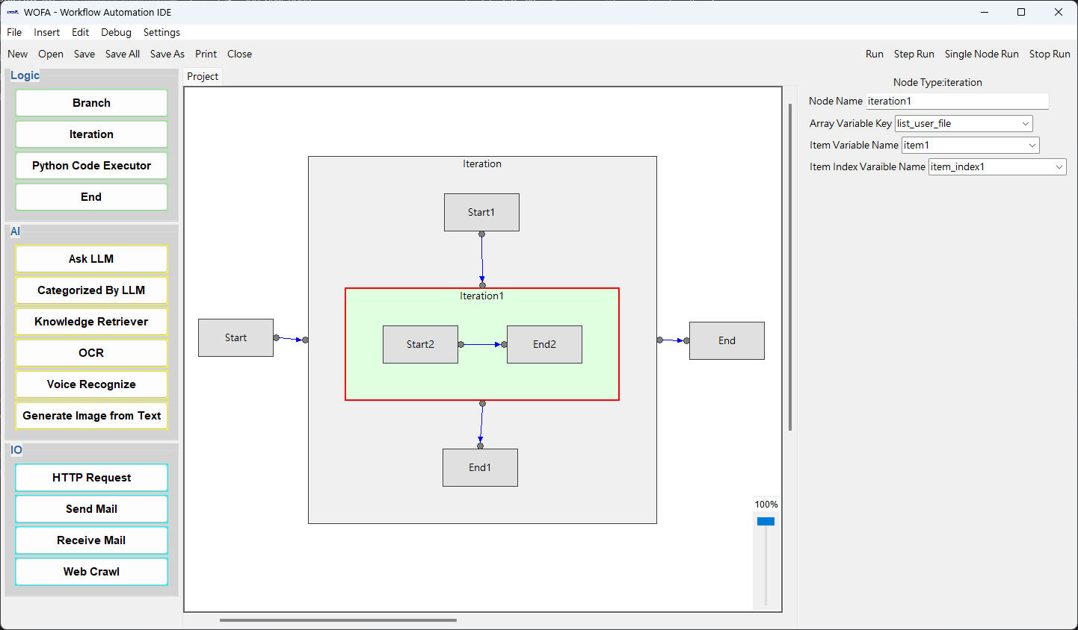
It is possible to insert another iteration node inside an iteration node.

Remember to add corresponding variables
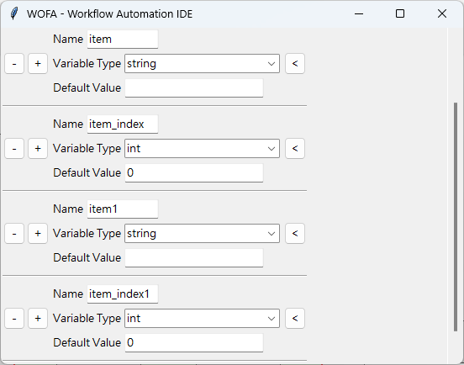
  - Python Code Executor
This node will store the values of the variables, which appear in the “Output Variables Key” and the code, into the project variables table with the same variable name.
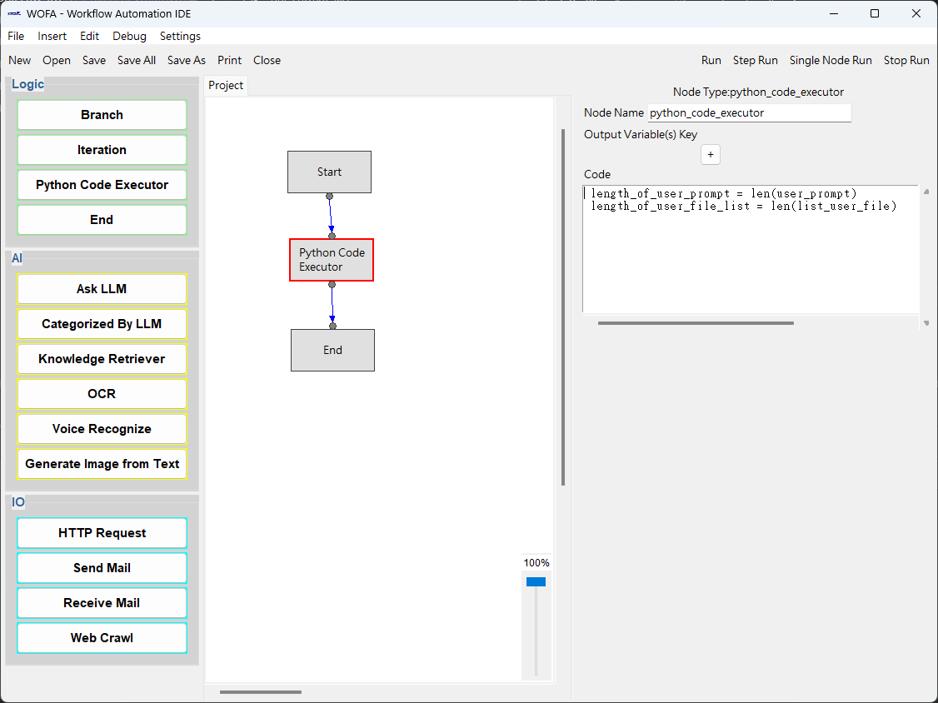
After inserting the node, the following appears:

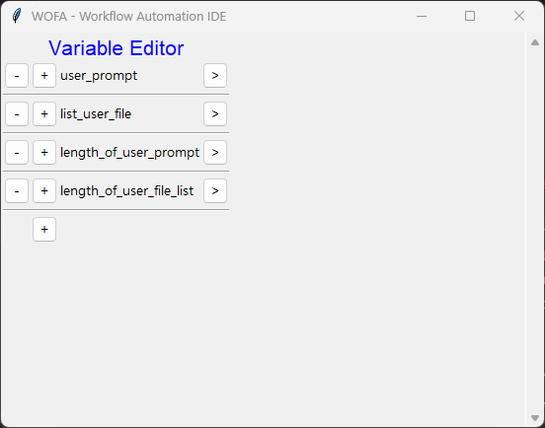
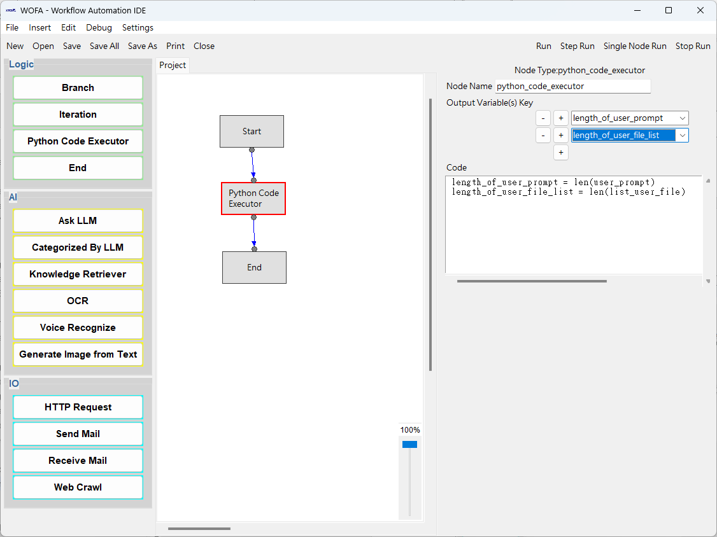
  - End
The workflow will be ended when arriving at this node. You can utilized the python code in the answer composer to compose the desired answer and store it in the designated variable.
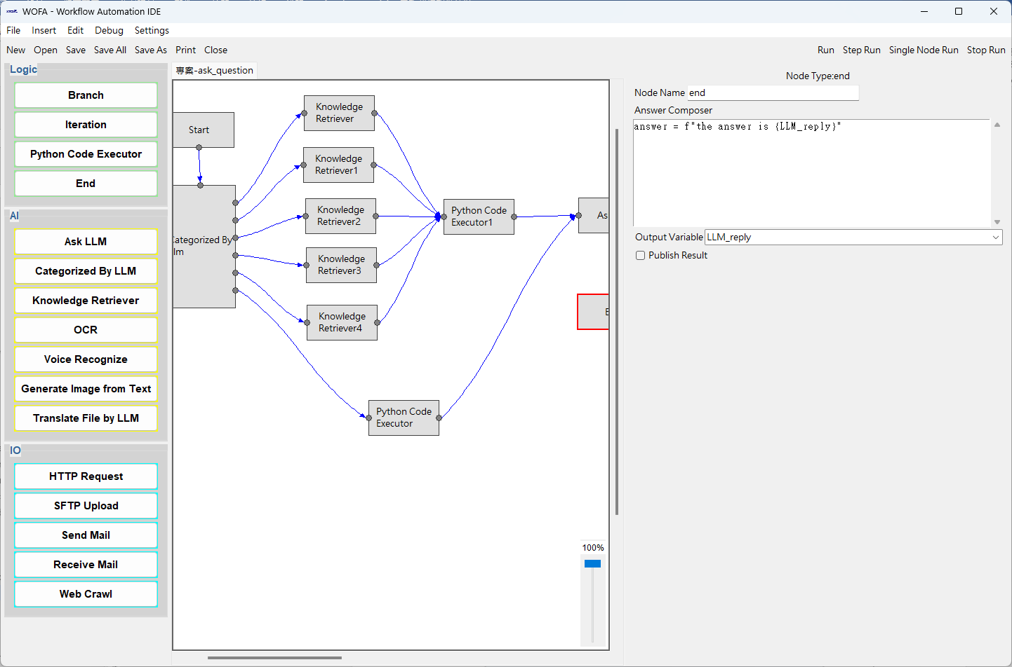
After inserting the node, the following appears:
It is possible to select “Publish Result” here, in order to post-process the reply from the LLM, store it in a variable, and notify the caller.
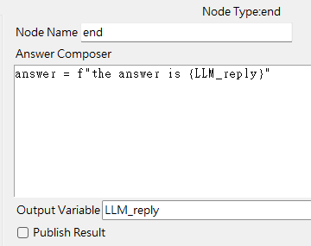
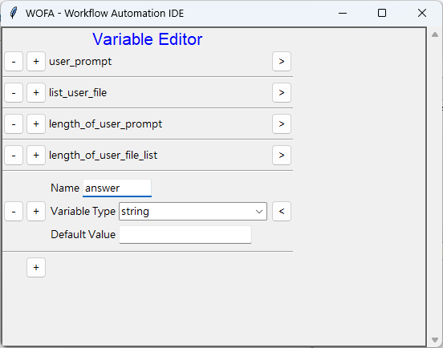

AI Model Nodes
  - Asking LLM
This node will send the system prompt, user prompt, user file list to the designated LLM, and specified the temperature assigned. The answer from LLM will be stored in the output variable assigned.
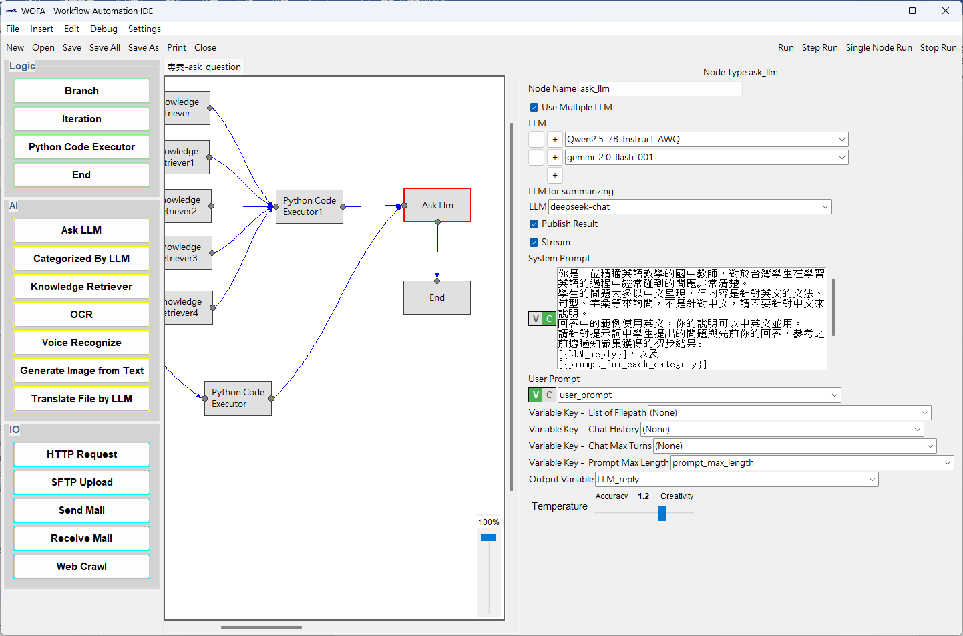
After inserting the node, the following appears:

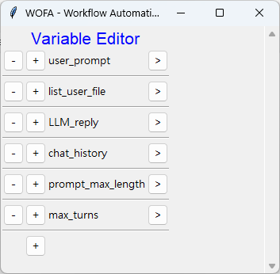
Assing the variables of “Chat History” and the “Chat Max Turns” will automatically combine the chat history with the user prompt.
The “Prompt Max Length” depends on each LLM and the user prompt will be trimmed accordingly.

Multiple LLMs can be selected to answer the question simultaneously and the replies can be summarized by the designated LLM.
The output from LLM can be stream (any reply from LLM will be echo to the caller).
It is also possible to choose whether to notify the caller after LLM completing the answer. If the choice is not to notify the caller at this stage, the notification should be done at node END, so that the caller will know the answer from the LLM is done.

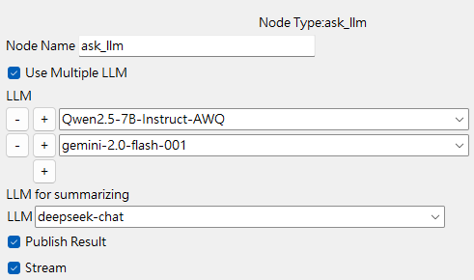
  - Categorize by LLM
This node will send the content of the variable to be categorized to the designated LLM, and ask the LLM to categorize the content according to the list of category, and return the position index of the category in the list, staring from 0.
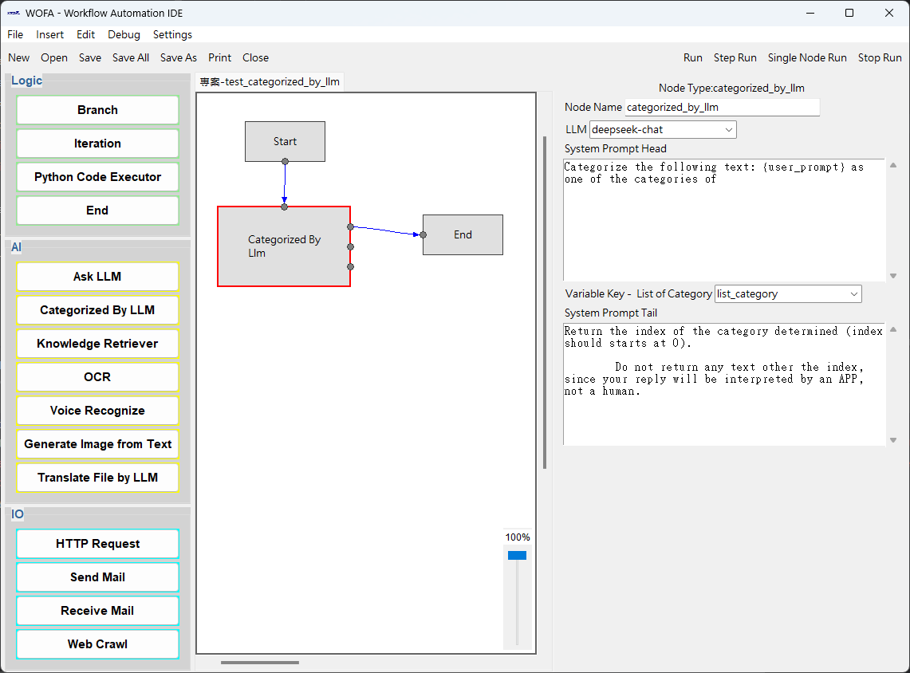
After inserting the node, the following appears:

  - Knowledge Retriever
This node will query the knowledge collections with the content of the input variable, the knowledge retrieved will be forwarded to designated LLM to organize the context and saved in the output variable.
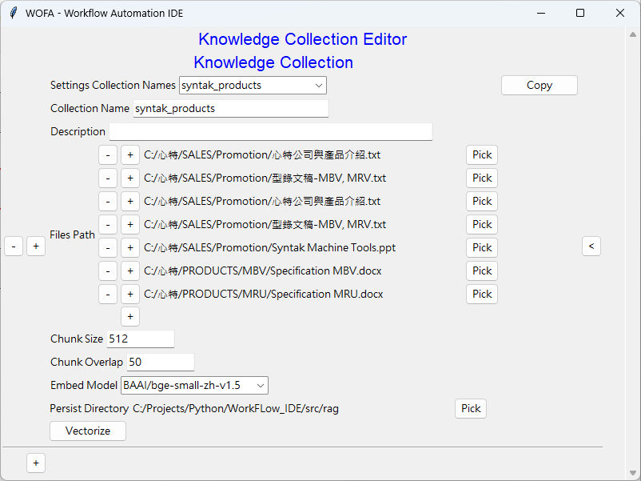
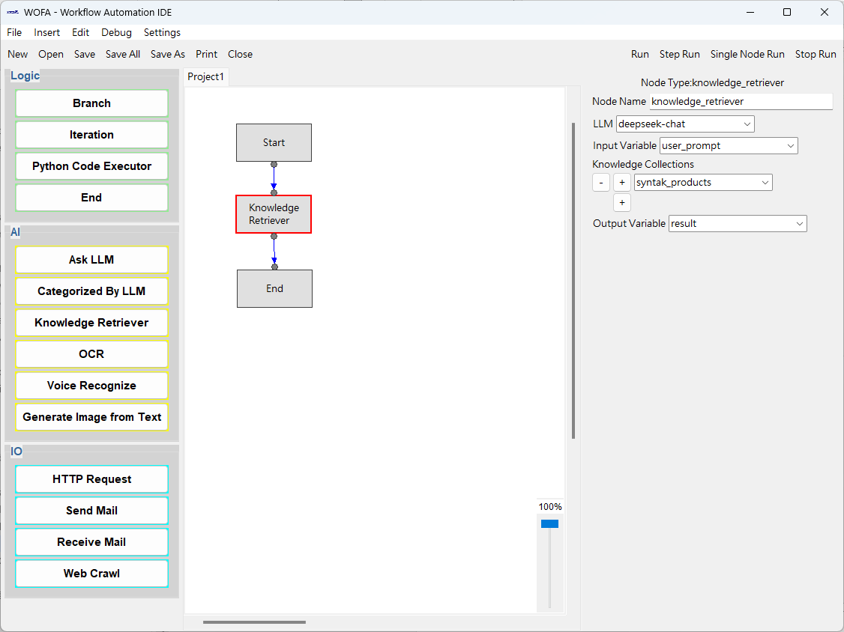
After inserting the node, the following appears:

  - OCR
This node will recognize the text in the image file and store the recognized text into the output variable.
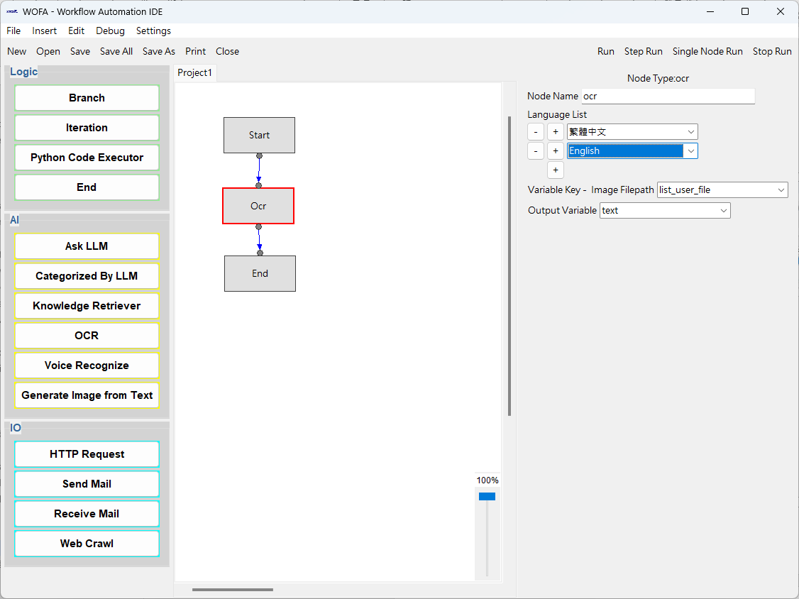
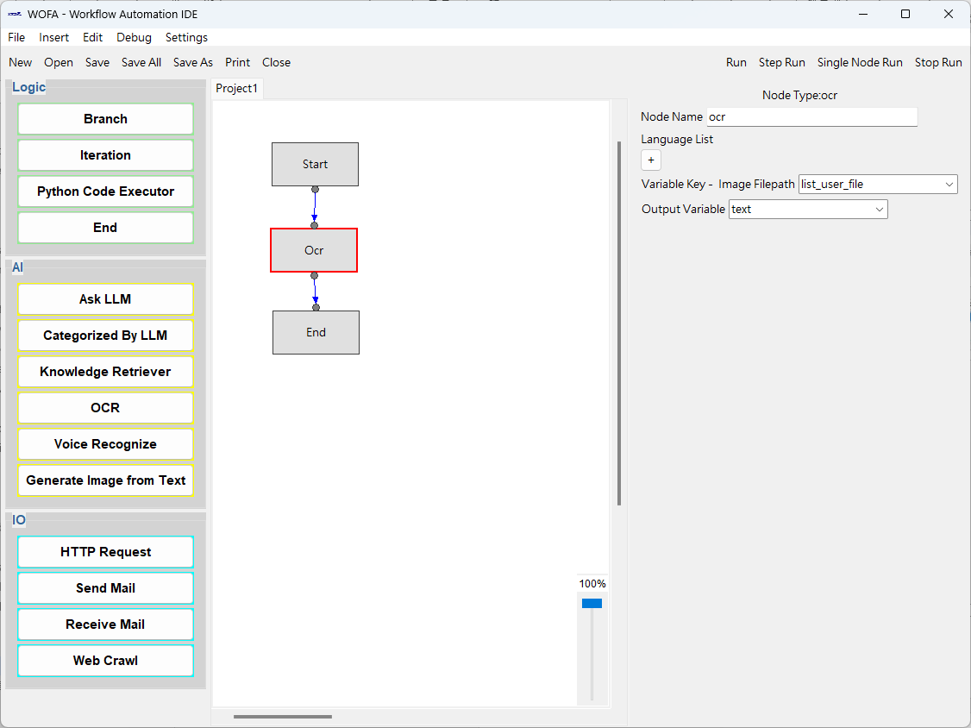
After inserting the node, the following appears:
  - Voice Recognize
This node will recognize the text in the voice files and store the recognized text into the output variable.
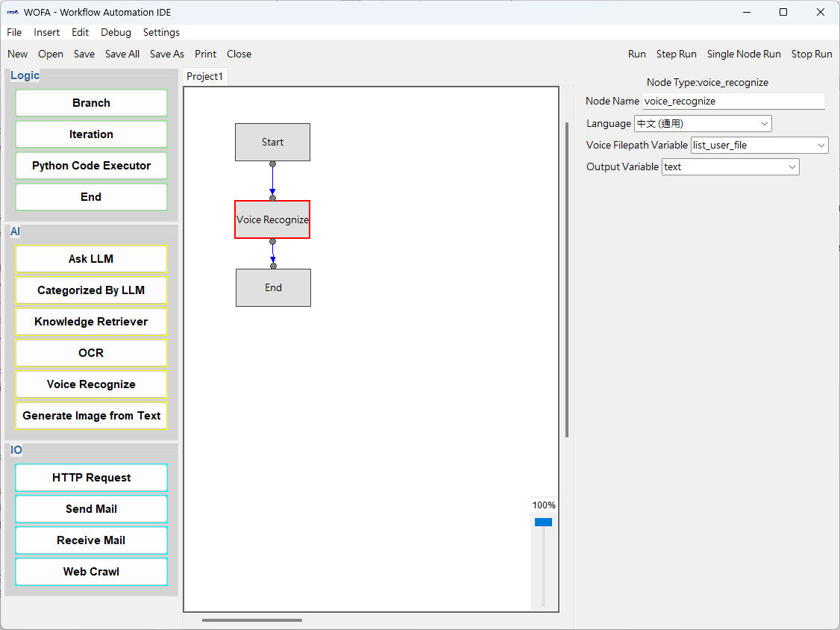
After inserting the node, the following appears:

  - Generate Image from Text
This node will generate image according to the prompt and the other parameters, and save the image into the file path designated.
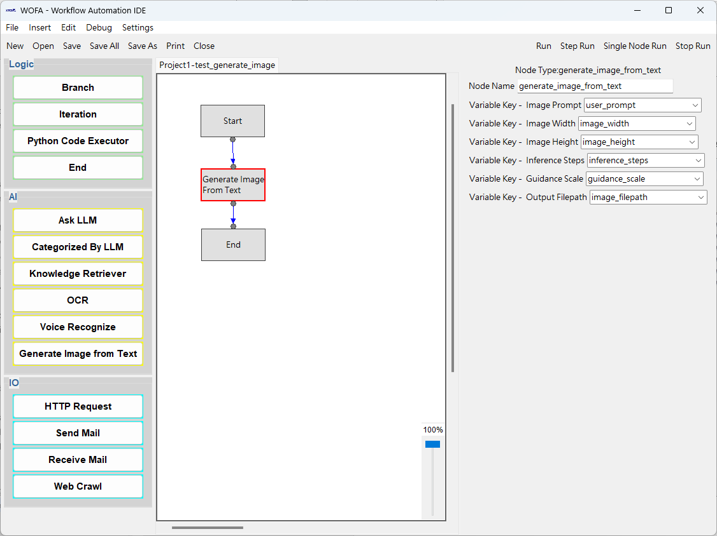
After inserting the node, the following appears:

  - File Translation
This node will translate the text file into the target language and save it to the designated file name and path.
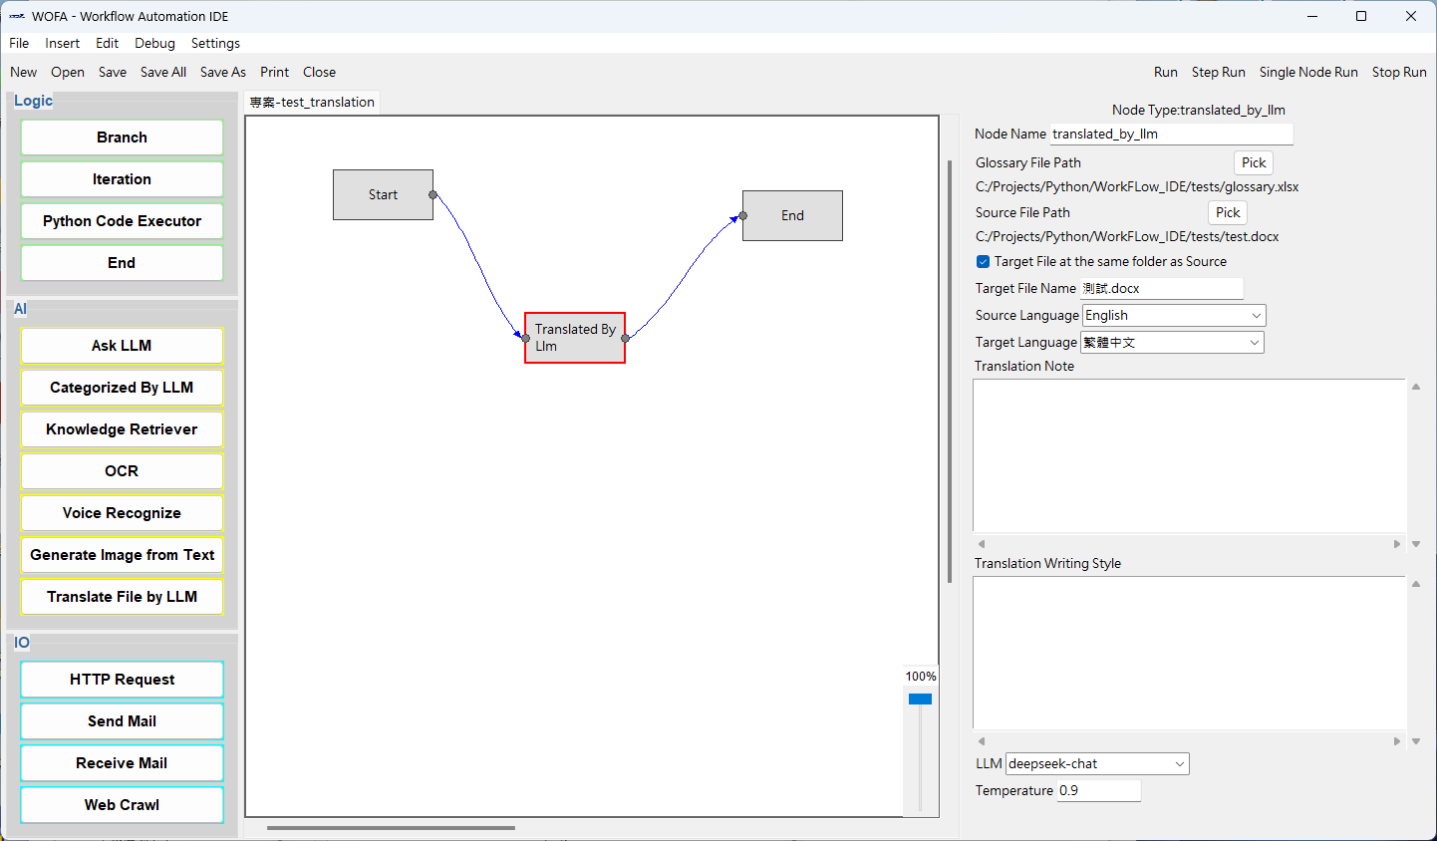
After inserting the node, the following appears:
A glossary.xlsx file must be provided to enhance the translation quality. The format will be like the example blow:
English | 繁體中文
WOFA - Workflow Automation IDE | WOFA - 工作流程自動化編輯除錯器
Settings | 設定
Language | 語言
File | 檔案
The first row is the name of the languages, which will appear in the languages related drop down menus
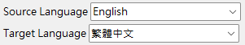
The demands in “translation note” and ”writing style” will be passed to LLM to implement the translation task.
Acceptable file formats includes: docx, doc, xlsx, xls, pptx, ppt, txt, html, md, pdf, etc. The node will not check the file format, please check them in advance.

I/O Nodes
  - HTTP Request
This node can send an HTTP request to designated URL and store the server reply into the output variable designated.
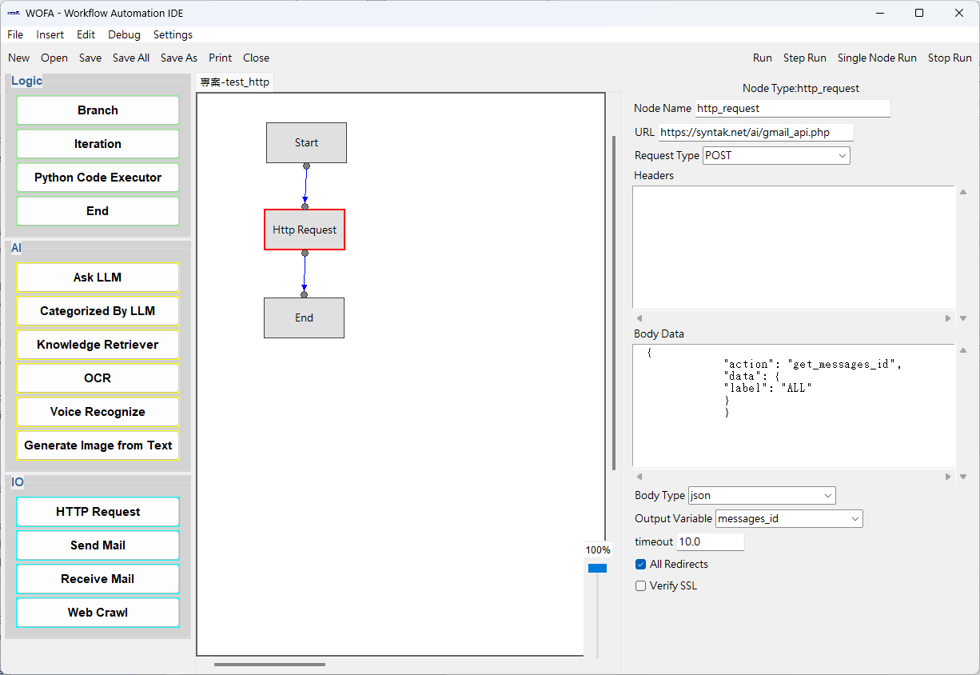
After inserting the node, the following appears:

  - Send Email
This node can send an email to the email address designated.
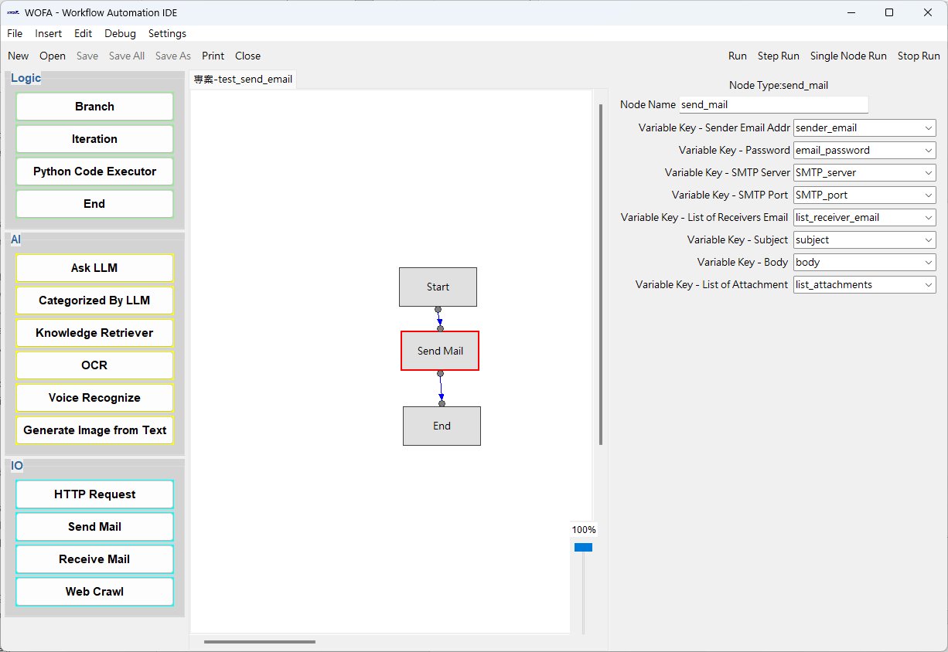
After inserting the node, the following appears:

  - Receive Email
This node can retrieve email related information from the mail account assigned.
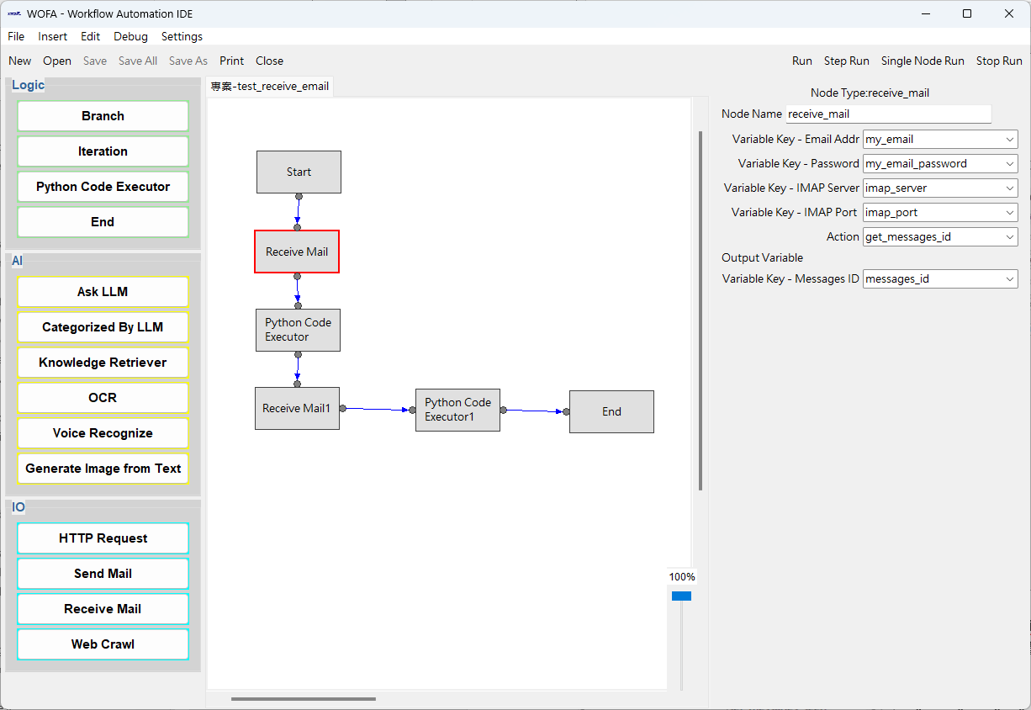
After inserting the node, the following appears:

The actions available are:
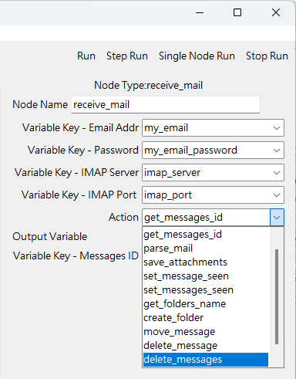
With the action “parse_mail”, you can get a dict with keys including:
"Subject", "From", "Date", “To", "Cc", "Body", "HTML_Body"

